Rodrigo Brasil 10/2023

### **Part 1: Topology 1/2**

Initial topology

**Part 2: Staging**

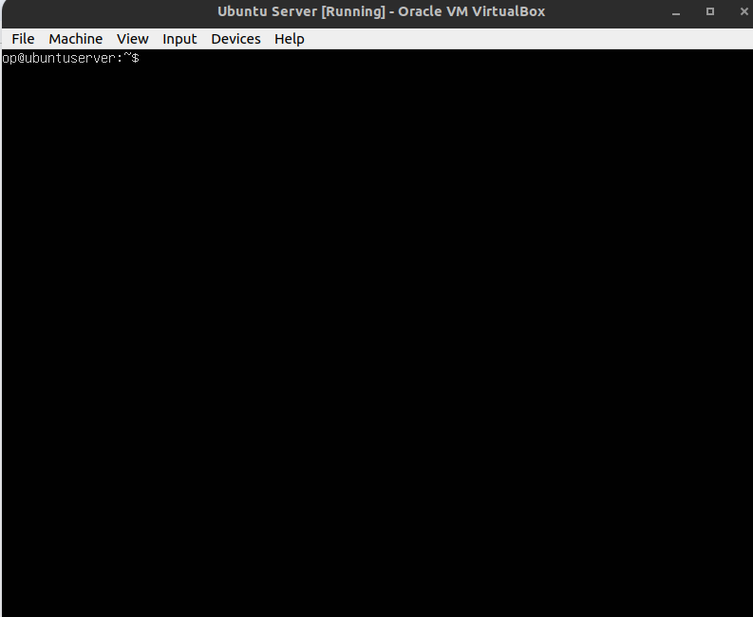

Ubuntu Server VM

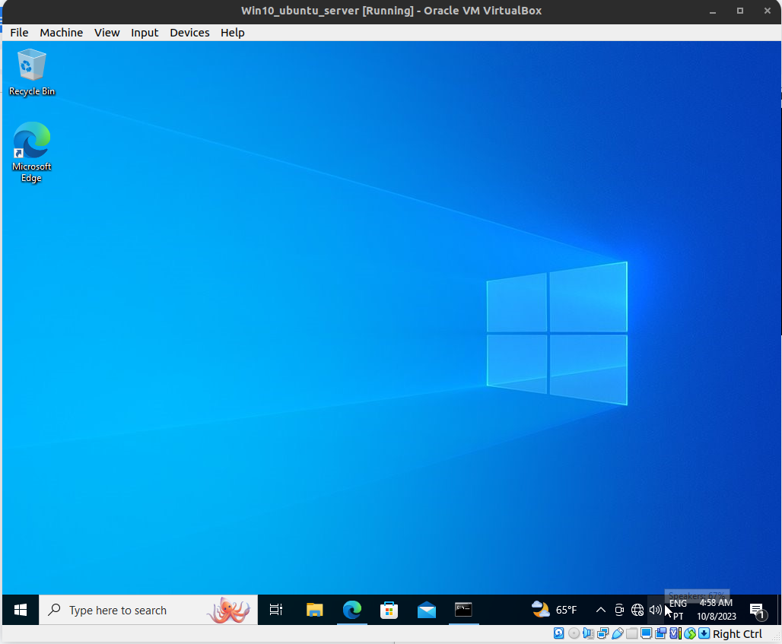

Windows 10 VM

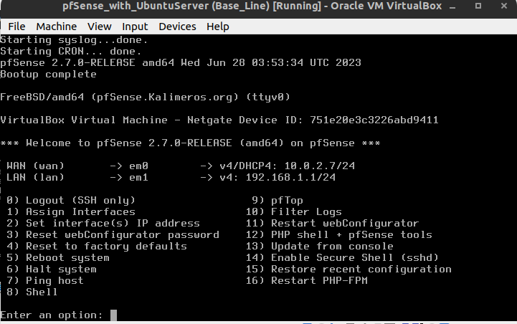pfSense VM

### **Part 3: NGINX Web Server Setup**

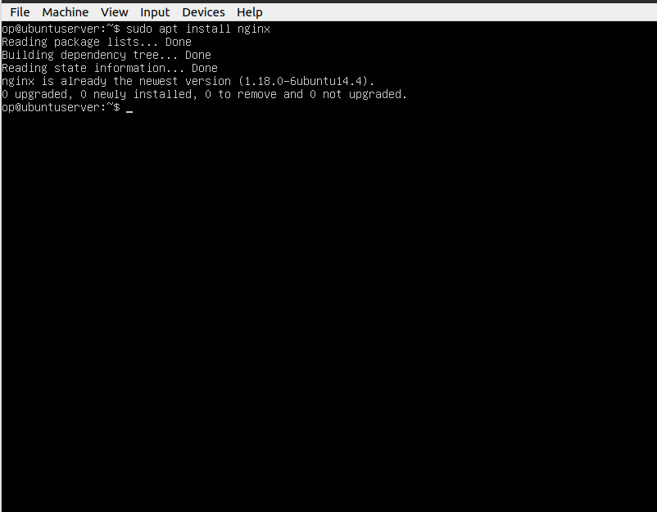

Installation of the nginx web server with the “apt install nginx” command

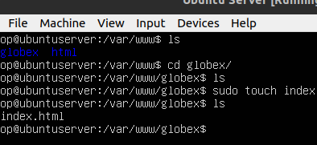

Entering the www directory with the cd command, creating a directory called globex with the mkdir command, entering the directory and creating a file named index.html with the touch command.

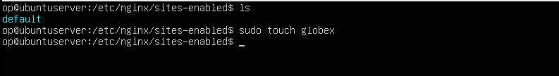

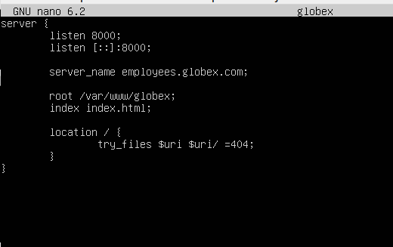

Creating the virtual host

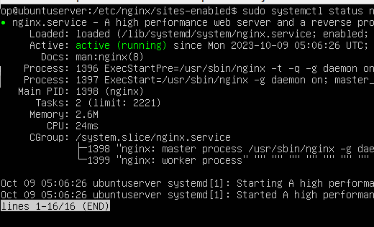

Nginx running

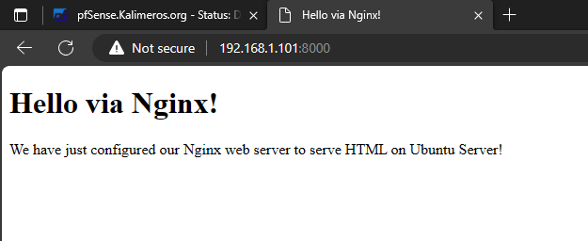

Successfully accessed the server via the windows 10 VM

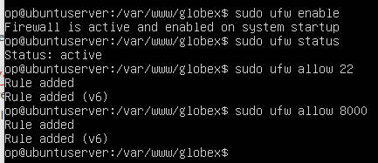

Activated ubuntu server ufw and allow access to ports 22 and 8000



Copied the new website page from the class repo to the server

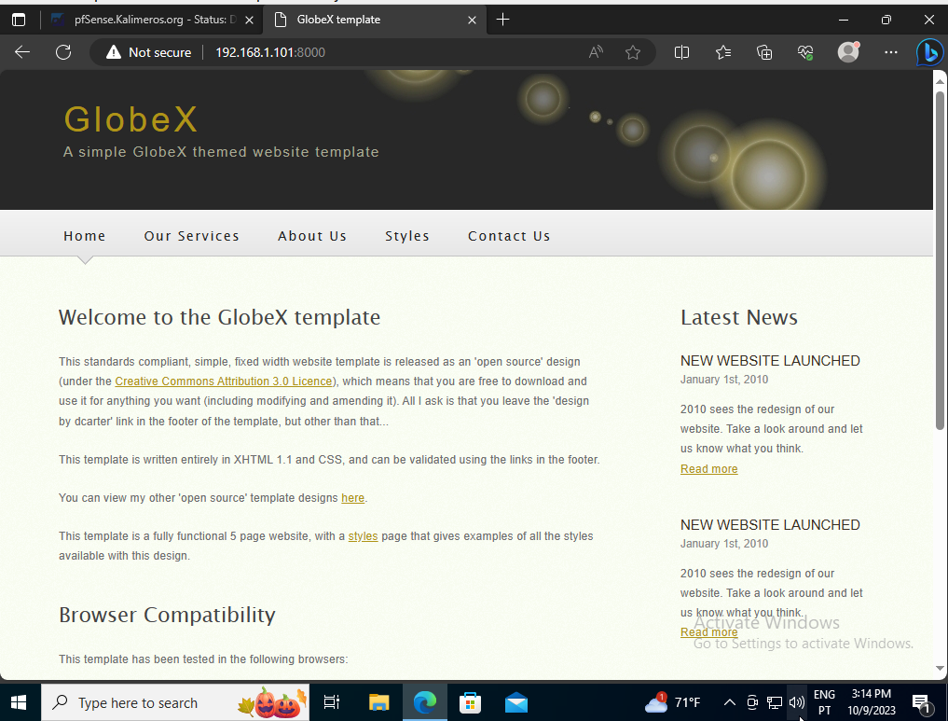

Accessing the new website on the windows 10 VM

### **Part 4: Configuring pfSense**

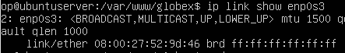

Ubuntu Server MAC Address determined

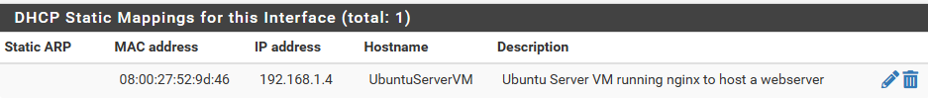

Added a static DHCP mapping to pfSense for the NGINX web server

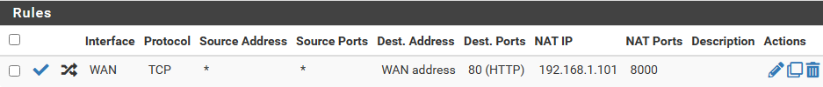

NAT rule created

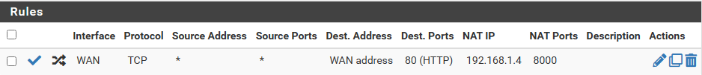

After restarting all the VM’s ubuntu’s server ip changed from 192.168.1.101 to 192.168.1.4

It didn't change before so after restarting couldn't access the website but resolved it by changing the ip address

### **Part 5: Testing**

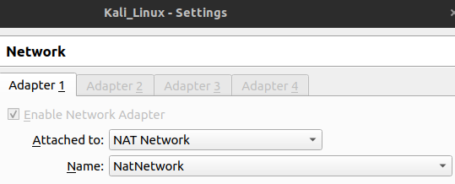

Kali VM on the NAT Network

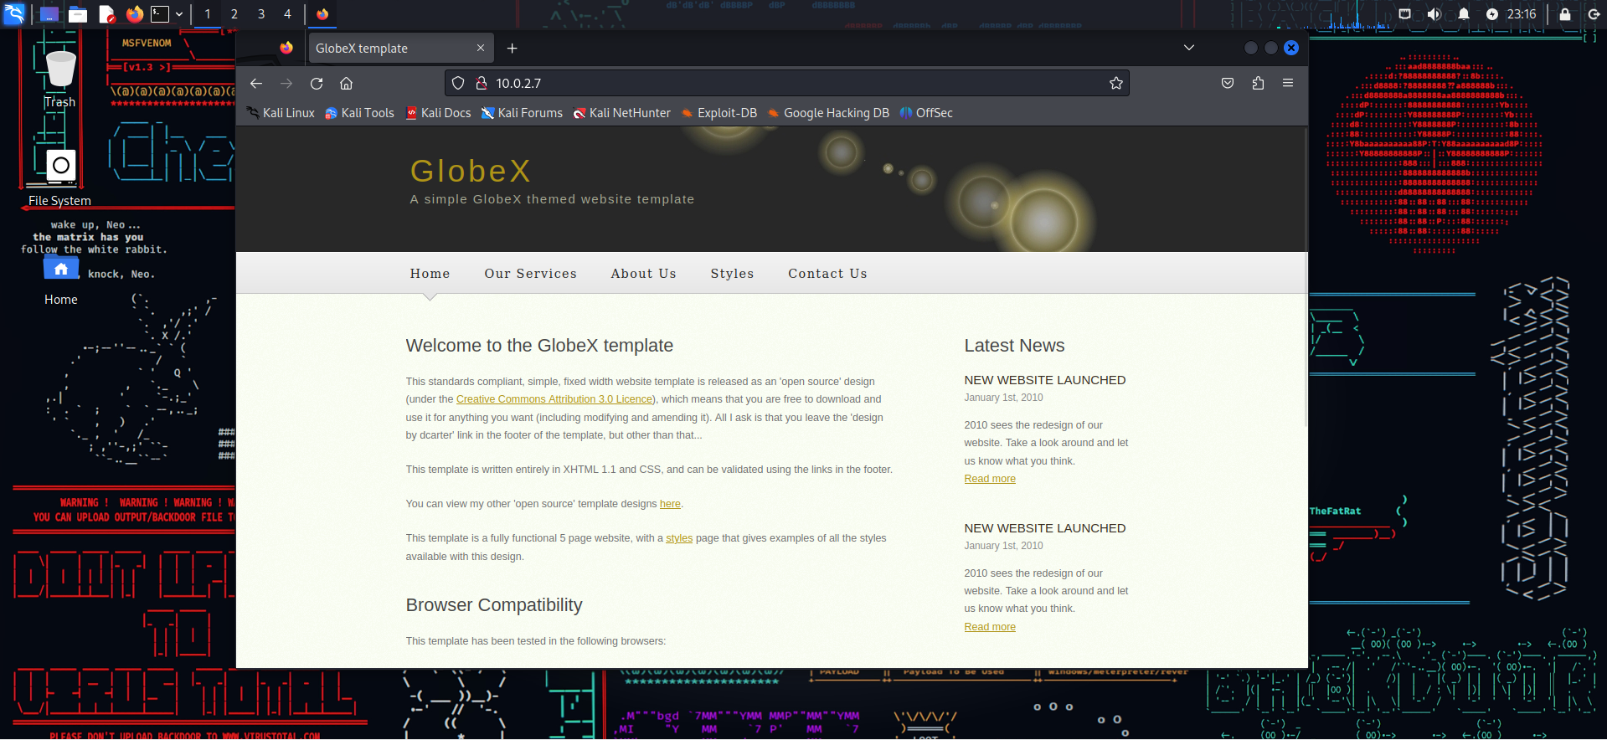

Successfully accessed the website with a kali VM on the NAT Network with the WAN IP address

### **Part 6: Topology 2/2**

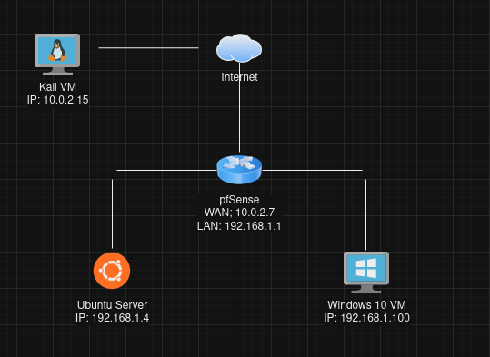

Final topology